3.1 Intro Homework - Angles Formed by a Transversal
Directions: Please read Section 3.1 Page 147 and/or go to Weebly to view the 3.1 Video to assist you in filling in the notes below. There will be a short vocabulary quiz tomorrow, so make sure you know it!

Something Old: Pairs of Angles formed by Two Intersecting Lines
1
2
3
4
Vertical Angles: Linear Pair Angles:

Something New: Pairs of Angles Formed by a Transversal
r
s
t
1
2
3
4
5
6
7
8

Transversal:

Corresponding Angles:

Alternate Interior Angles: Same Side Interior Angles:

Alternate Exterior Angles: Same Side Exterior Angles:

You Try! For # 1– 6, give an example of each type of angle pair:

1) Corresponding Angles: ________________________
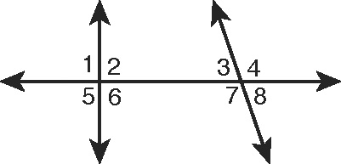
2) Alternate Interior Angles: ________________________
3) Same Side Interior Angles: ________________________
4) Alternate Exterior Angles: ________________________
5) Vertical Angles: ________________________
6) Linear Pair Angles: ________________________
Self – Assessment: Rate your understanding on a scale of 1 to 5 with
1 being “I have no idea” and 5 being “I got this!”
Corresponding Angles: 1 2 3 4 5
Alternate Interior/Exterior Angles: 1 2 3 4 5
Same Side Interior/Exterior Angles: 1 2 3 4 5
What are you going to do to better understand the vocabulary you do not fully understand?

